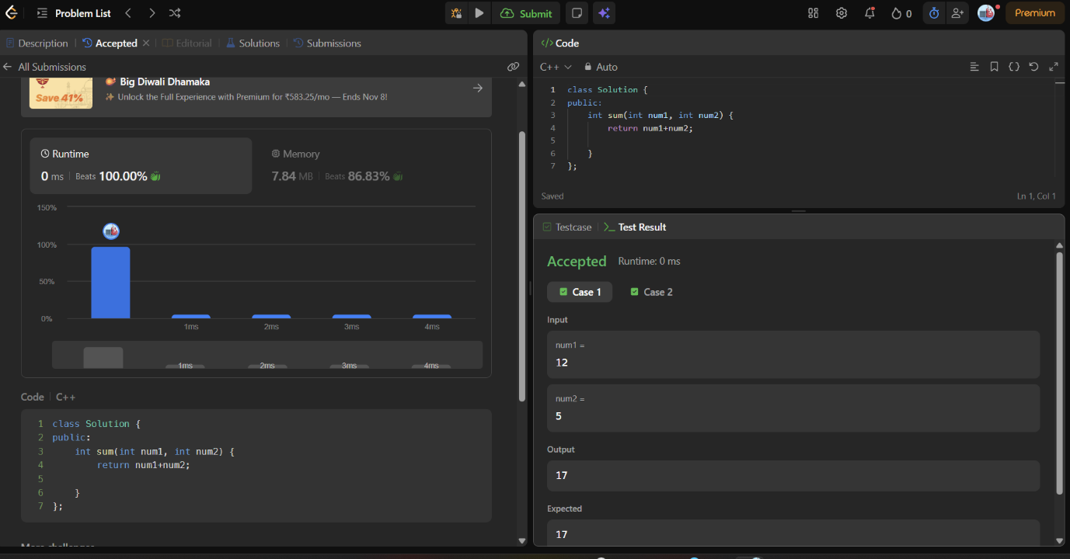
class Solution {
public:
int sum(int num1, int num2) {
return num1+num2;

}
};

